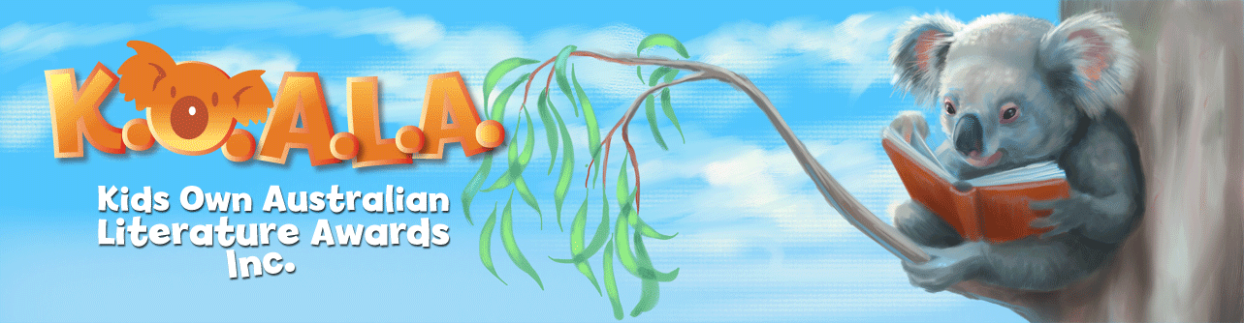

LIST OF KOALA WINNERS FROM 2010
PICTURE STORY booksBOOKS | Year
 | 2010 Fearless Colin Thompson & Sarah Davis
 | 2011 Mr Chicken goes to Paris Leigh Hobbs
 | 2012 Fearless in Love Colin Thompson & Sarah Davis
 | 2013 The Very Cranky Bear Nick Bland
 | 2014 The Dreadful Fluff Aaron Blabey
 | 2015 Pig the Pug Aaron Blabey
 | 2016 Pig the Fibber Aaron Blabey
 | 2017 Do Not Open This Book Andy Lee and Heath McKenzie
 | 2018 Do Not Open This Book, Again! Andy Lee and Heath McKenzie
 | 2019 Seriously, Do Not Open This Book Andy Lee and Heath McKenzie

YOUNGER READERS | 2010 The Big Fat Cow that goes Kapow Andy Griffiths & Terry Denton
 | 2011 The Very Bad Book Andy Griffiths & Terry Denton
2012 Tashi and the Golem Anna Fienberg, Barbara Feinberg & Kim
Gamble
 | 2013 The Golden Door Emily Rodda
 | 2014 Billie B. Brown: The Best Project Sally Rippin
 | 2015 Billie B. Brown: The Bully Buster Sally Rippin and Aki Fukuoka
 | 2016 The Bad Guys: Episode 1 Aaron Blabey
 | 2017 The Bad Guys: Episode 2 Aaron Blabey
 | 2018 Weirdo 8: Really Weird Anh Do and Jules Faber
 | 2019 The Bad Guys Episode 7: Do-You-Think-He-Saurus?! Aaron Blabey
OLDER READERS | 2010 The Battle for Rondo Emily Rodda
 | 2010 The Wizard of Rondo Emily Rodda
 | 2011 Book of Lies James Moloney
 | 2012 The 13 Storey Treehouse Andy Griffiths & Terry Denton
 | 2013 The 26 Storey Treehouse Andy Griffiths & Terry Denton
 | 2014 The 39 Storey Treehouse Andy Griffiths & Terry Denton
 | 2015 The 52 Storey Treehouse Andy Griffiths & Terry Denton
 | 2016 The 65 Storey Treehouse Andy Griffiths & Terry Denton
 | 2017 The 78 Storey Treehouse Andy Griffiths & Terry Denton
 | 2018 The 91 Storey Treehouse Andy Griffiths & Terry Denton
 | 2019 The 104 Storey Treehouse Andy Griffiths & Terry Denton
YEARS 7-9 | 2010 Boy Overboard Morris Gleitzman
 | 2011 Girl Underground Morris Gleitzman
 | 2012 The Phoenix Files: Arrival Chris Morphew
 | 2013 The Phoenix Files: Contact Chris Morphew
 | 2014 Pennies for Hitler Jackie French
 | 2015 Two Wolves Tristan Bancks
 | 2016 Soon Morris Gleitzman
 | 2017 Pennies for Hitler Jackie French
 | 2018 The Fall Tristan Bancks
 | 2019 Maybe Morris Gleitzman

