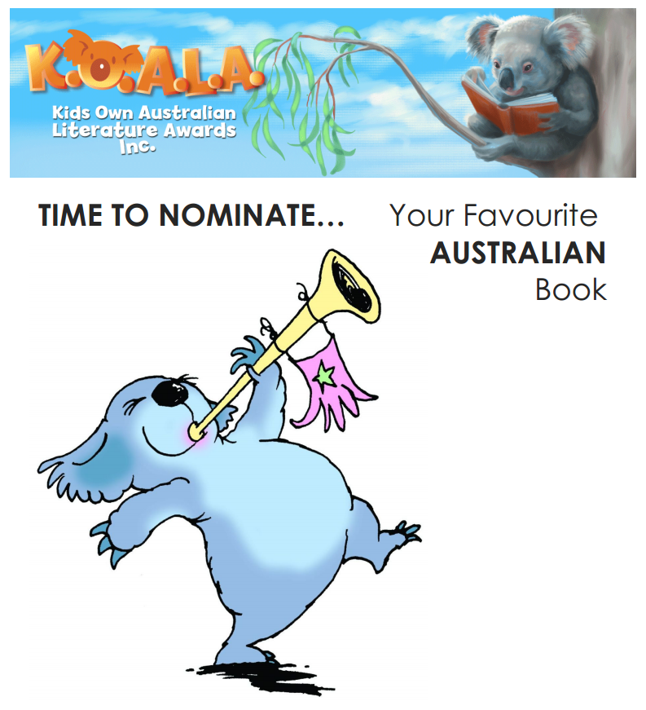
You may nominate up to 4 books for the 2020 KOALA Awards. Remember these four criteria for nominating:
- The book must be Australian.
- The book must have been published since 2011.
- The book must not be a previous winner (Check previous winners list).
- Nominations must be for a specific title e.g. Selby Surfs not Selby books.

